Lab2- U24AI041
Exercise 1:
Que 1:
Create a table Student with these fields:
RollNo Number (6), Name Character (25), Semester Number (3), DOB Date,
AdmissionDate Date, HostelRoom Number (5)
Insert 10 Rows in the above created table.
Query:
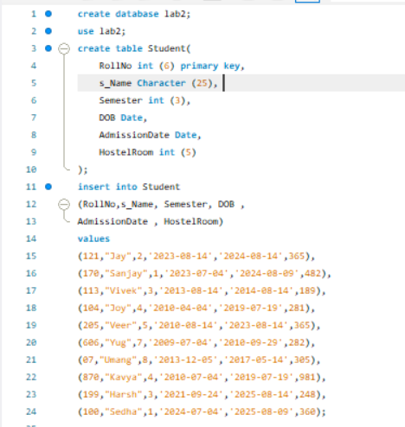
OUTPUT:
Task:
1. Student table with all columns and rows.
O/P: 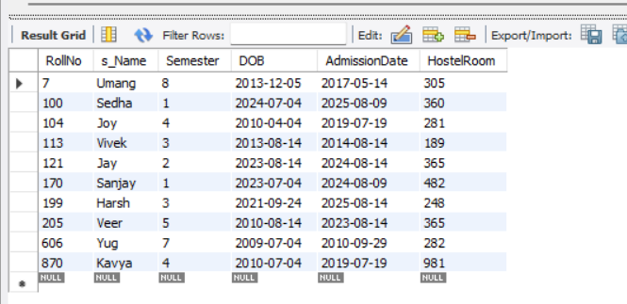
2. Student details with columns Roll number and Name only.
O/P: 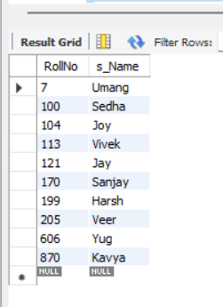
3. Student details of all the students who are in 4th semester.
O/P:
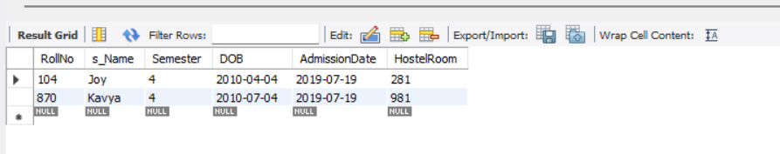
4. Student details of all the students whose roll number is between 100 to 200.
O/P: 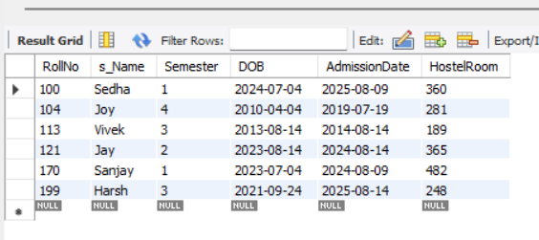
5. Student details of all the students whose DOB is greater than 1st jan 2001.
O/P: 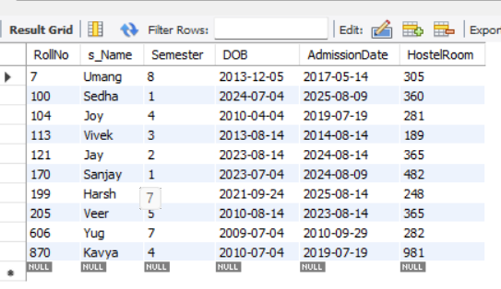
6. Student details of a student with enrollment number ‘07’
O/P: 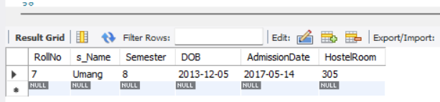
7. Students who reside on the second floor in the hostel.
[Hint: Hostel Room’s initial number gives the floor]
O/P: 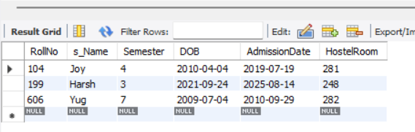
8. Students whose name starts with ‘S’
o/p: 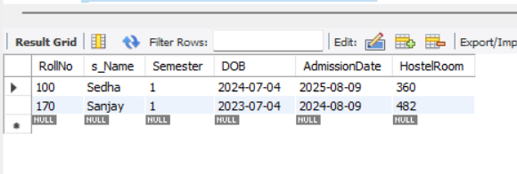
Query:
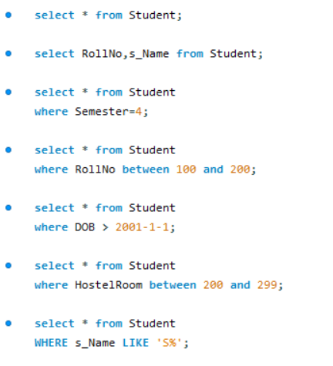
OUTPUT:

Exercise 2:
Que 1:
Create a table Employee with these fields:
EmpID Number (6), Name Character (25), Department Character (30), ManagerID
Number (6), JoiningDate Date, Salary Number (8)
Insert 10 Rows in the above created table.
Query:
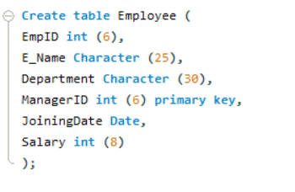
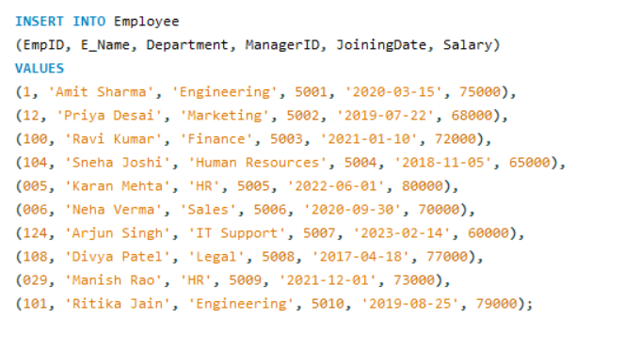
OUTPUT:
Task:
- Employee table with all columns and rows.
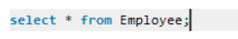
O/P:
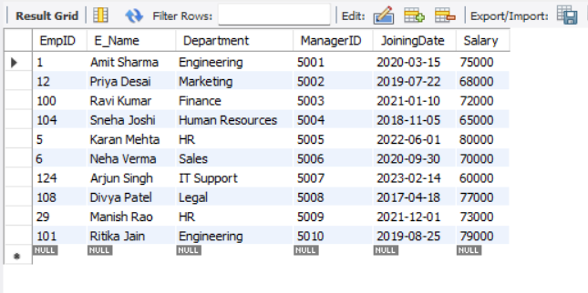
- Employee details with columns Name and Department only.
O/P:
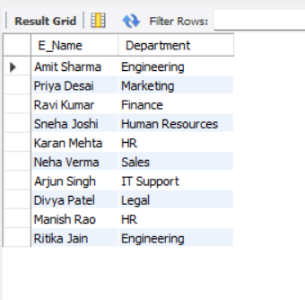
- Employee details of all the Employees who are in HR department.
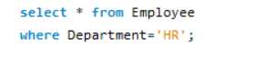
O/P:
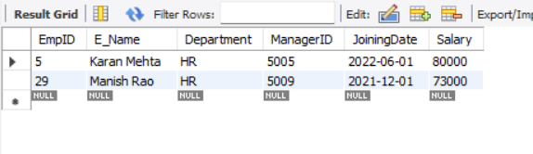
- Employee details of an employee whose EmpID is ‘124’
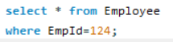
O/P:
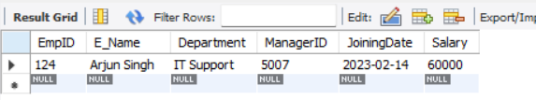
- Employee details of all the Employees whose salary is between 50000 to 100000.
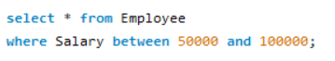
O/P:
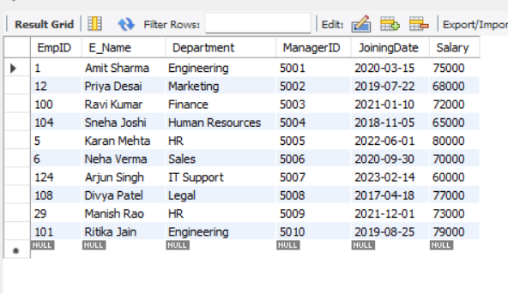
- Employee details of all the Employees whose JoiningDate is greater than 1st jan2020.
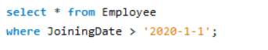
O/P:
